***PAAREES PERFUMES***

***DAVIDOFF***

***FOR WOMEN***

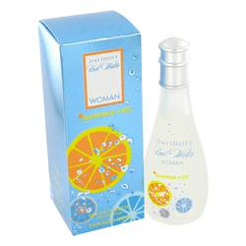

***Cool Water Summer Fizz***

***Description:***

Cool Water Summer Fizz by Davidoff Perfume. Cool Water Summer Fizz for women is like a pitcher of sangria and a fresh fruit salad. Sweet notes of pineapple, apple, peach, mulberry, black currant, water lily, honeydew and raspberry rule this fragrance. A fresh sea breeze accords freshens things up and balances well against the warm tones of amber, musk, and sandalwood.